

**Fundamentals of Programming Home task 8**

**Name: Muhammad Amad Naeem**

**CMS ID: 467469**

**Section: ME-15 B**

**Professor: Affan**

**Task 1:**

**#include <bits/stdc++.h>**

**using namespace std;**

**int main(){**

**int n;**

**cout<<"enter the number of elements for array"<<endl;**

**cin>>n;**

**int arr[n];**

**cout<<"enter the elements :"<<endl;**

**for(int i=0;i<n;i++){**

**cin>>arr[i];**

**}**

**cout<<"the most repeated elements in the array is/are :"<<" ";**

**for(int i=0;i<n;i++){**

**bool repetation=false;**

**for(int j=0;j<i;j++){**

**if(arr[i]==arr[j]){**

**repetation=true;**

**break;**

**}**

**}**

**if(!repetation){**

**for(int j=i+1;j<n;j++){**

**if(arr[i]==arr[j]){**

**cout<<arr[i]<<" ";**

**break;**

**}**

**}**

**}**

**}**

**return 0;**

**}**

**Output:**

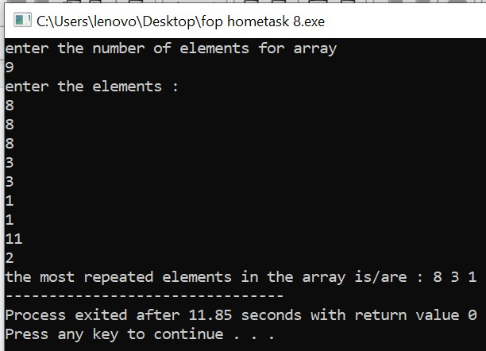

**Task2:**

**#include <bits/stdc++.h>**

**using namespace std;**

**int main(){**

**int arr[8]={13,15,17,9,99,77,65,43},max=0;**

**int i,temp=0;**

**for(i=1;i<8;i++){**

**if(arr[max]<arr[i]){**

**temp=arr[max];**

**arr[max]=arr[i];**

**arr[i]=temp;**

**}**

**}**

**int j,min=7,temp2=0;**

**for( j=1;j<8;j++){**

**if(arr[min]>arr[j]){**

**temp2=arr[min];**

**arr[min]=arr[j];**

**arr[j]=temp2;**

**}**

**}**

**cout<<"Max number: "<<arr[max]<<endl;**

**cout<<"Min number: "<<arr[min];**

**return 0;}**

**Output:**

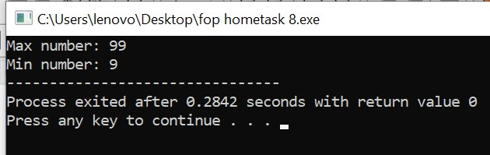

**Task3:**

**#include <bits/stdc++.h>**

**using namespace std;**

**int main(){**

**int arr[5];**

**for(int i=0;i<5;i++){**

**cout<<"Enter integer "<<i+1<<" :";**

**cin>>arr[i];**

**cout<<endl;**

**}**

**int temp=0;**

**temp=arr[4];**

**arr[4]=arr[2];**

**arr[2]=temp;**

**cout<<"Array after swapping: ";**

**for(int j=0;j<5;j++){**

**cout<<arr[j];**

**}**

**return 0;}**

**Output:**

